Bighorn 550 Soft Cab Enclosure Installation Instructions

550 Soft Cab Enclosure
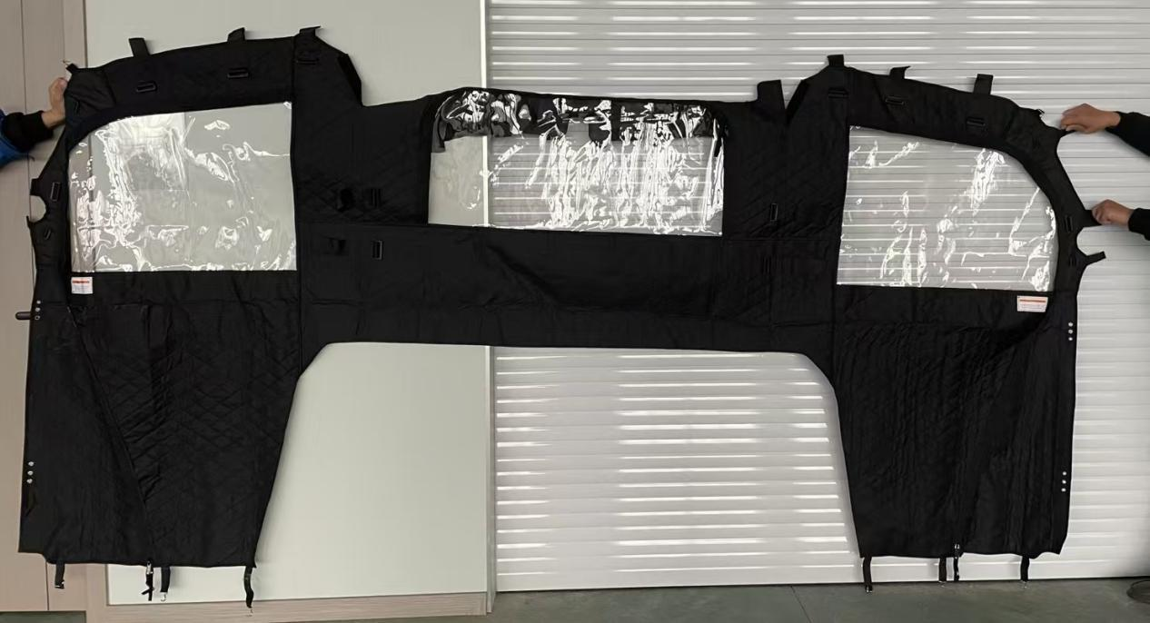

Diagram
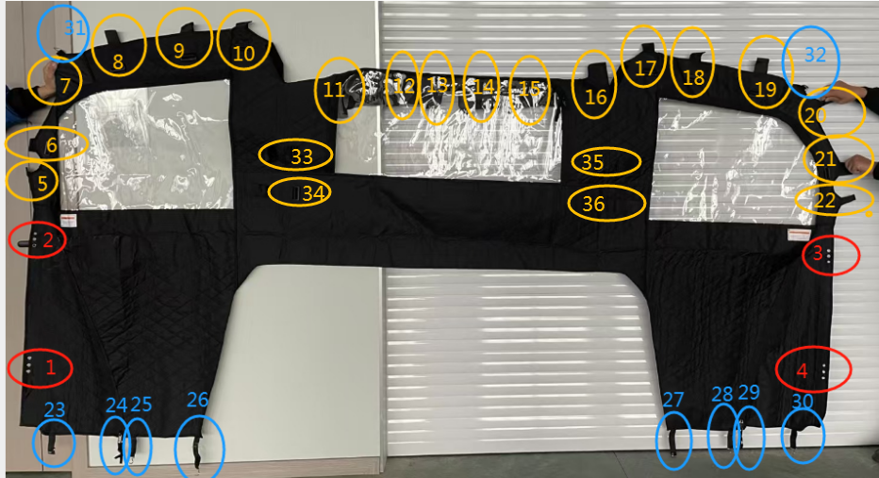

Installation Steps

(1) fix positions 1, 2, 3, and 4 to the designated locations on the vehicle. Then, tighten the bolts to secure the soft package, as shown in the diagram.

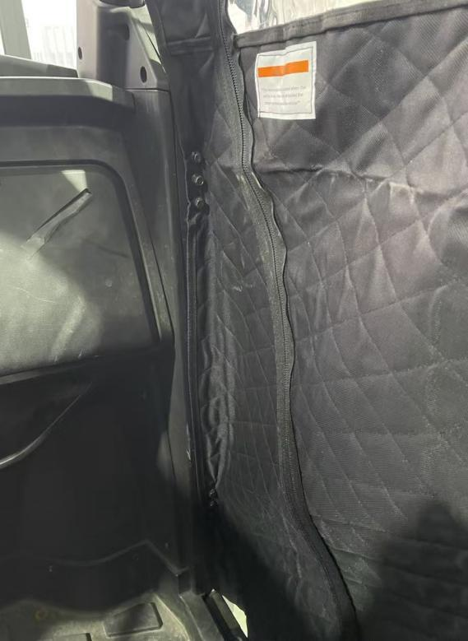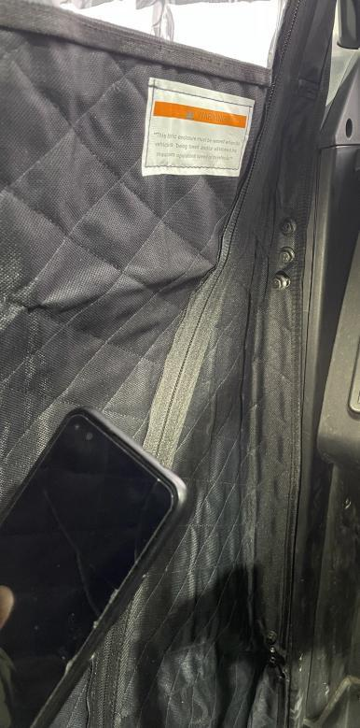

(2) Fasten the buckles at positions 5, 6, 7, 20, 21, and 22 to the designated locations on the vehicle. As shown in the diagram.

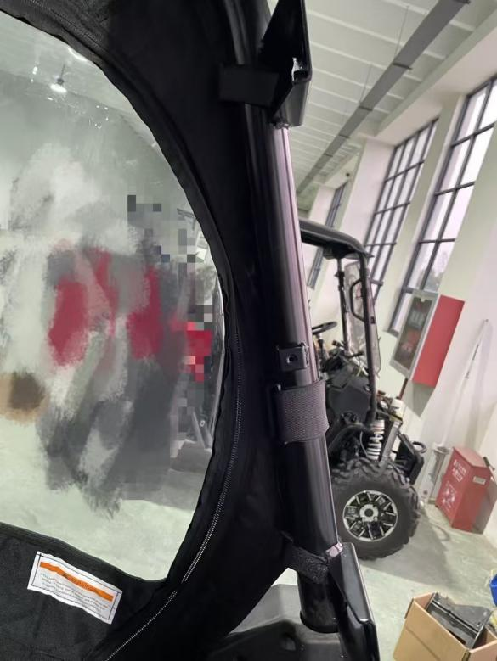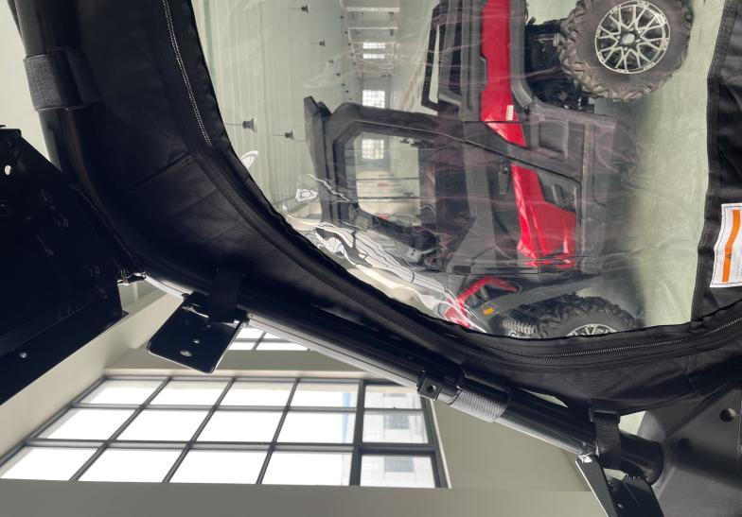

(3) Fasten the buckles at positions 8, 9, 10, 17, 18, and 19 to the designated locations on the vehicle. As shown in the diagram.

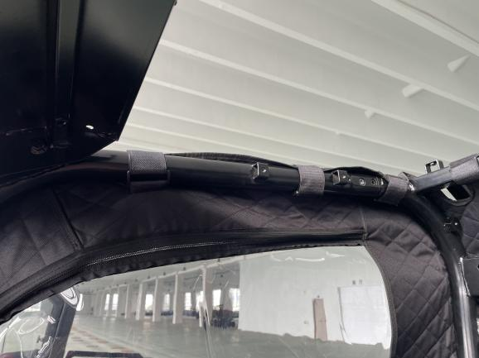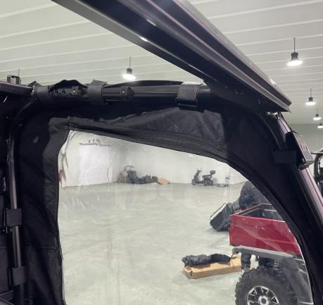

(4) Attach the buckles at positions 11, 12, 13, 14, 15, 16, 23, 34, 35, and 36 to the designated locations on the vehicle. As shown in the diagram.

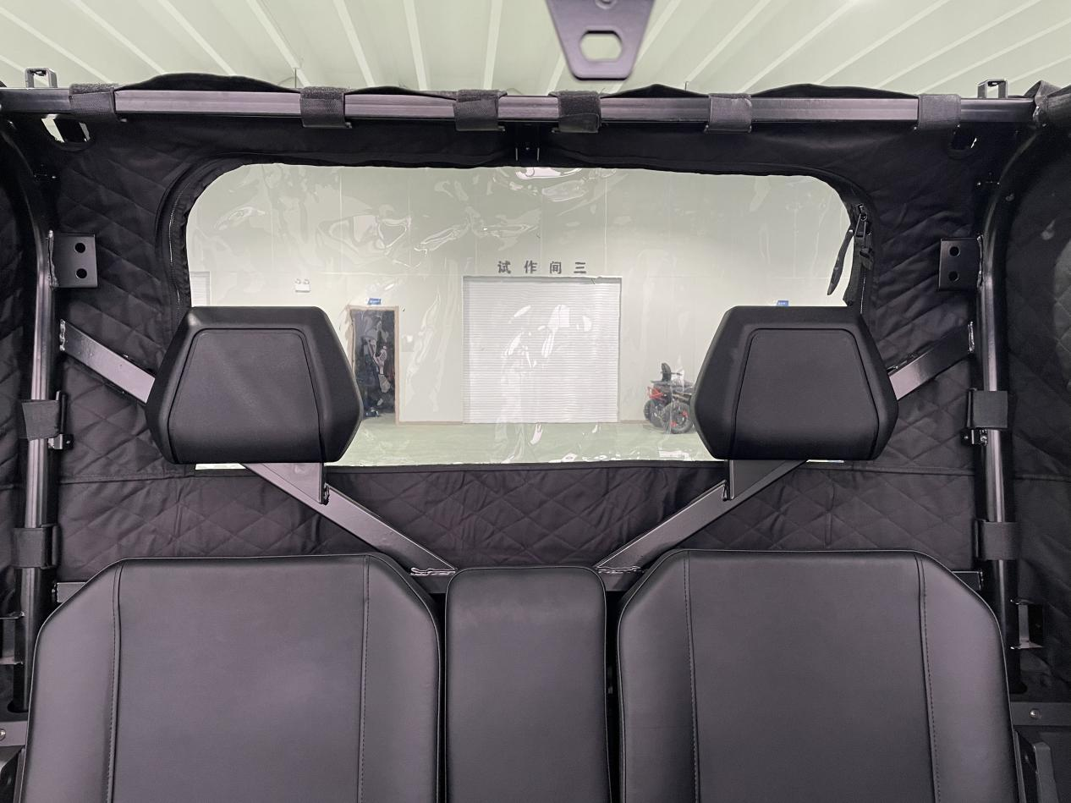

(5) Fasten the hooks at positions 31 and 32 to the designated locations on the vehicle, as shown in the diagram.
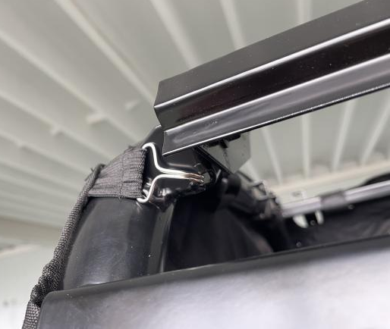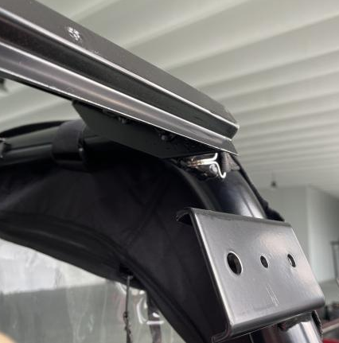

(6) Fasten the hooks at positions 23, 25, and 26 to the specified locations on the bottom of the vehicle. As shown in the diagram.

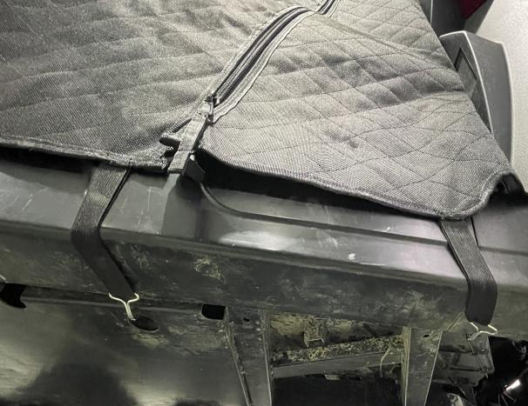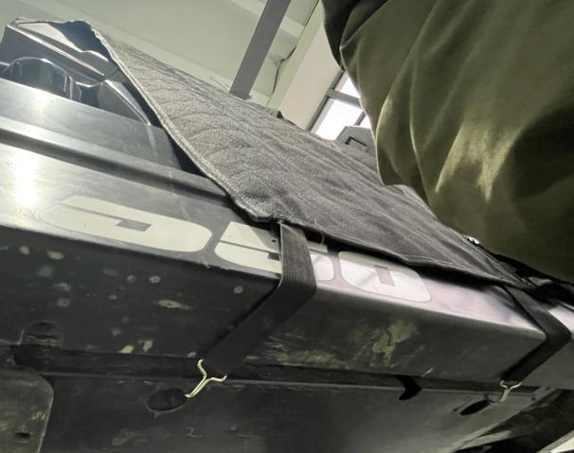

(7) Fasten the hooks at positions 27, 29, and 30 to the specified locations on the bottom of the vehicle. As shown in the diagram. Positions 24 and 29 are the zippers on both sides of the soft package.
